1. What causes a concurrency conflict?

Two users attempt to update the same entity at the same time.

1. What happens when concurrecy is not handled?

The last user’s changes to update the entity are save while the other user’s changes are completely lost.

1. Briefly describe the 3 options for applying Optimistic Concurrency.

The first option is to track both users’ changes only applying the unique changes between the two’s changes. The second option is to let the user that applied their changes second overwrite the first’s. The third option is to prevent the second user from updating the database.

1. What two ways does EF Core handle concurrency?

EF Core Checks that the property has not been modified after it was fetched during the SaveChanges or SaveChangesAsync methods.

EF Core also checks if there have been no rows updated by an update or delete command throwing a Concurrency Exception when it occurs.

1. What exception is thrown when a concurrency violation is detected?

DbUpdateConcurrencyException.

1. What data attribute is used on the rowversion column to enable concurrency tracking?

TimeStamp

1. What is the name of the built-in T-SQL variable that contains the number of rows affected by a SQL statement?

@@ROWCOUNT

1. Do a screen print verifying that migrations and scaffolding of the Departments table and model have been applied.

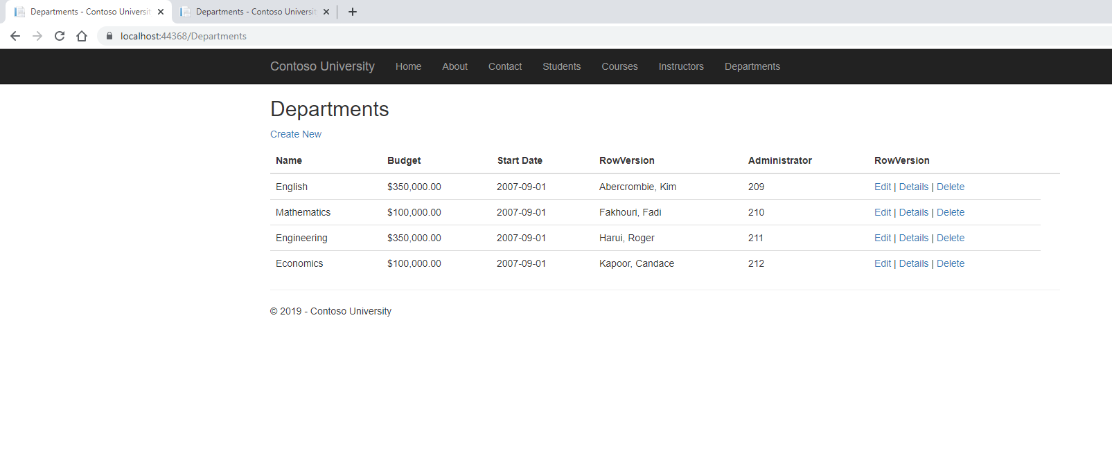

1. Do a screen print demonstrating the concurrency handling while editing your choice of departments. (two separate browser windows must be used).

First Window Submit: 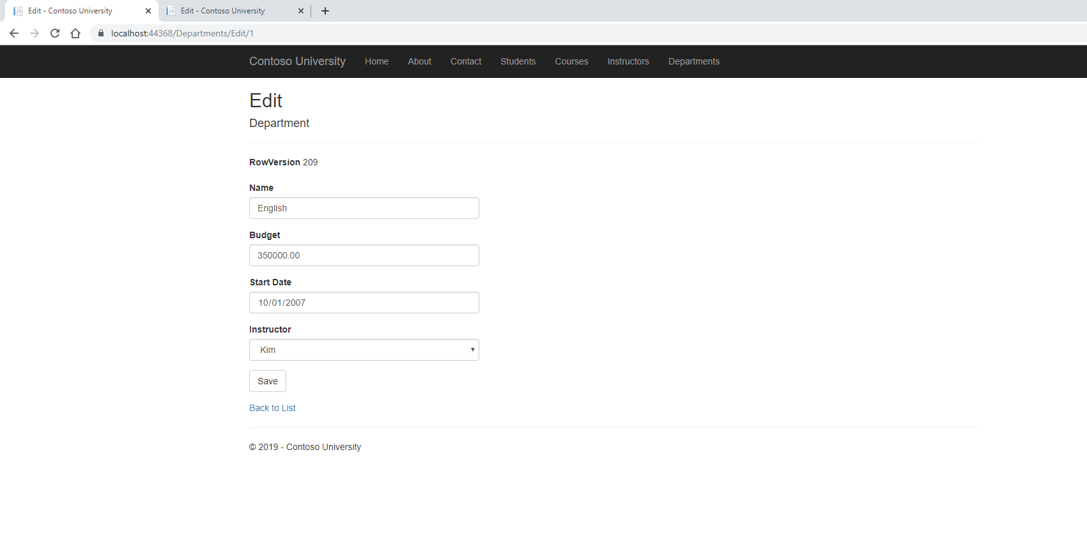

Second Window Submit:

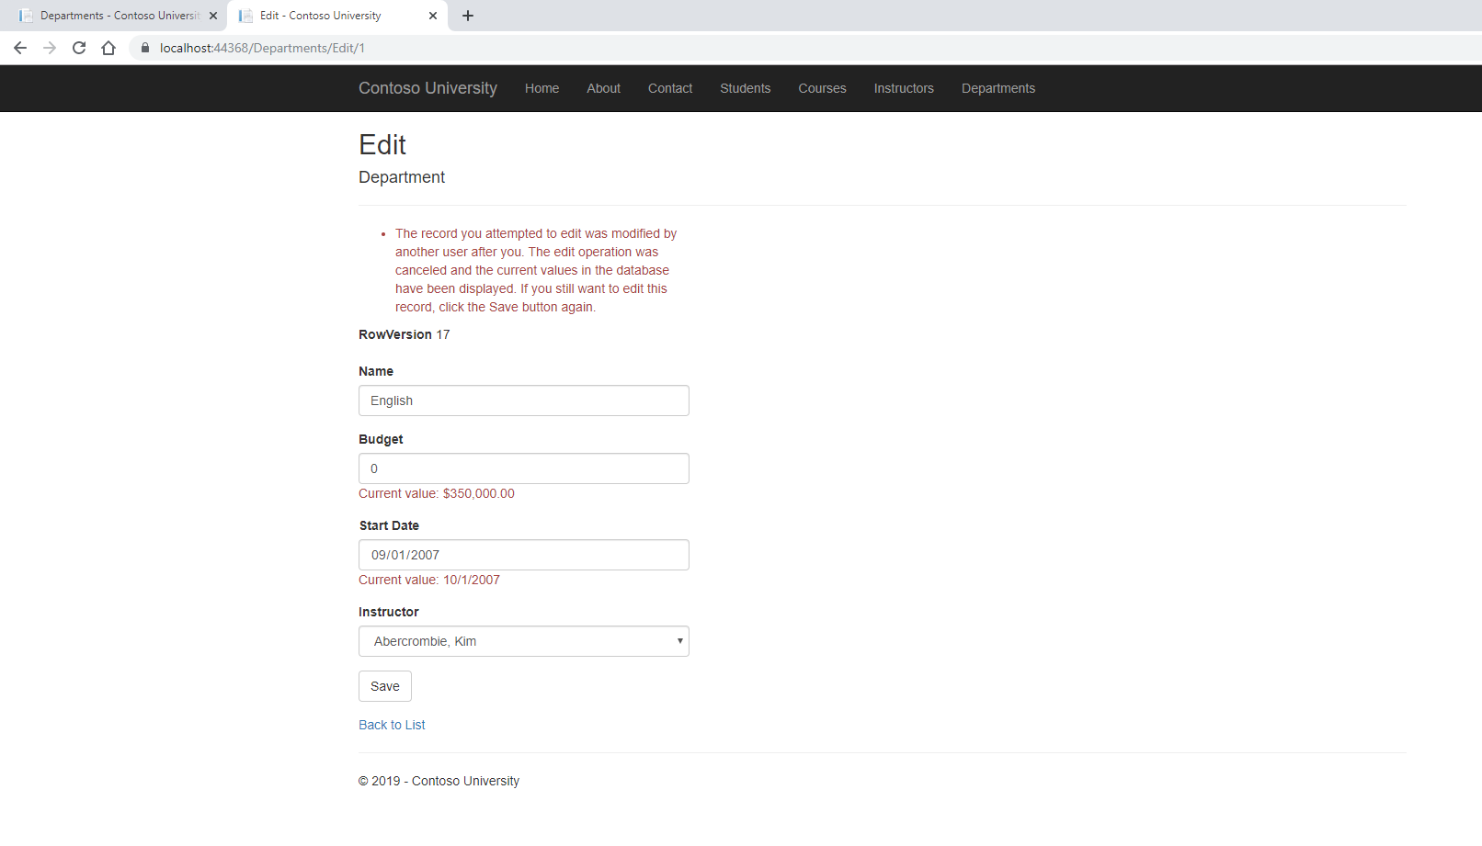

1. Do a screen print demonstrating the concurrency handling when deletion of a department occurs. (two separate browser windows must be used).

First Window Deletion: 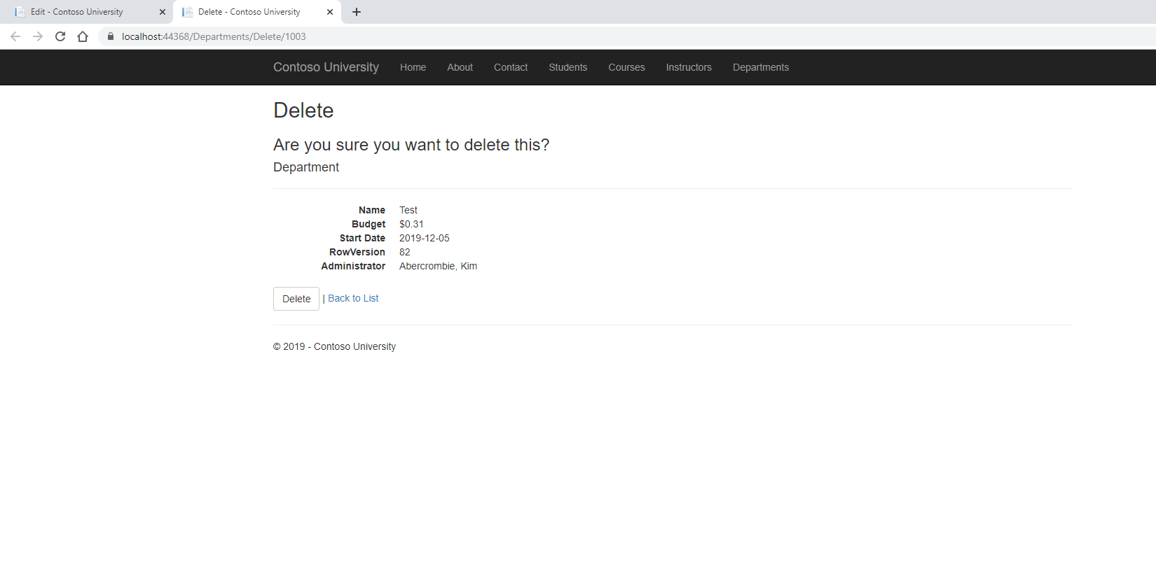

Second Window Editing: